

press release no. 8

SERVICE GUIDE
TTG TRAVEL EXPERIENCE and InOut THE CONTRACT COMMUNITY

www.ttgexpo.it

Rimini, 10th October 2023 – Arriving at Rimini Expo Centre and staying in the Rimini area is easier with the services developed for TTG Travel Experience e InOut operators and the public (11th – 13th October 2023).

► ENTRY TO THE EXPO CENTRE: the show can be accessed through the SOUTH, EAST and WEST entrances

► OPENING TIMES: 10 am –6 pm; last day: 10 am – 5 pm

►TICKET OFFICE: free entry on invitation, the show is strictly B2B and is therefore not open to the general public. Access to the visitors' area and the ticket section is subject to being registered on the following link: https://www.ttgexpo.it/visita/reserved-area

►THE DISABLED: Rimini Expo Centre offers the disabled easy access and viability inside the premises by providing the following services: reserved parking, entrances with ramps, push-open doors, interconnected one-floor halls, spacious refreshment areas that offer freedom of movement, specially-equipped bathrooms, conference rooms located on the upper floor that can be reached by lift, railway station on the Milan-Bari line that can be accessed by lift, mobility aids (manual wheelchairs), bookable for the days of the show. Rimini Expo Centre offers the possibility – on prior booking – to use mobility aids (wheelchairs) free of charge on the days of the show. To forward the booking, send the specific form (downloadable here) to HELP DESK. You will receive booking confirmation.

► SPECIAL TRAINS: you can come to Rimini Expo Centre directly by train (Regional, Intercity, Frecce), which, on event days, stops at the station inside the Expo Centre just 50 metres from the southern entrance to the event. Timetable information can be found at www.trenitalia.com (by typing in the exact day of departure or arrival and RiminiFiera station).

► CAR ROUTES, CAR RENTAL AND TAXIS: The Expo Centre is connected to the A14, Bologna – Bari – Taranto motorway and is 6 Km from the Rimini North motorway exit and 7 km from the South exit. Info: https://www.iegexpo.it/it/venues/rimini/quartiere. For Taxis call (+39) 0541/50.020. Electric carsharing is also available and can be booked on the app. For car rental, see AVIS Autonoleggio (https://www.avisautonoleggio.it/).

► PARKING: Rimini Expo Centre has space for 11,000 vehicles, subject to parking fees.

► PUBLIC TRANSPORT: Rimini Expo Centre is well served by a regular bus service. Tram line no. 9 (from the airport with a stop at Rimini railway station), no. 9 bis (from Rimini railway station with no intermediate stops) and two other dedicated tram lines: no. 5 departing from San Mauro Mare, and no. 10 departing from Miramare.
Info www.tramservizi.it or www.startromagna.it/servizi/orari-e-percorsi/

► BOLOGNA AIRPORT: An airport shuttle bus service will be available from Bologna airport with a direct connection to Rimini Expo Centre (on exhibition days) and a daily service operates from Bologna airport to Rimini (Station, via Fada). Info www.riminiairport.com
► METROMARE: is the new public transport system that connects Rimini and Riccione stations in 23 minutes, stopping at 15 intermediate stations. The service runs daily every 20 minutes. Timetable downloadable here.
► ELECTRIC MICRO-MOBILITY: Bicycles and electric scooters are available from Lime (vehicle parking areas are located at the South Entrance and inside the Expo Centre’s EAST 1-2, WEST 1-2 car parks) and BIT Mobility (located at the South Entrance and inside the Expo Centre’s EAST 1-2, WEST 1-2 car parks).

►HOTEL AND TRAVEL BOOKINGS: hotels can be booked directly online at https://www.ttgexpo.it/ttg/strumenti/prenota-hotel

► ARRIVING BY HELICOPTR: Rimini Expo Centre has a helipad. The email address to contact is: roberta.sarti@iegexpo.it

ABOUT: TTG TRAVEL EXPERIENCE
Event: international trade show; organiser: Italian Exhibition Group SpA; frequency: annual; edition: 60th; entry: trade only; website: www.ttgexpo.it - #ttgexpo

ABOUT: INOUT, THE CONTRACT COMMUNITY
Event: international trade show; organiser: Italian Exhibition Group SpA; frequency: annual; edition: 1st edition of INOUT which unites SIA, SUN, SUPERFACES, GREENSCAPE; entry: trade only; website: www.inoutexpo.it #inoutexpo

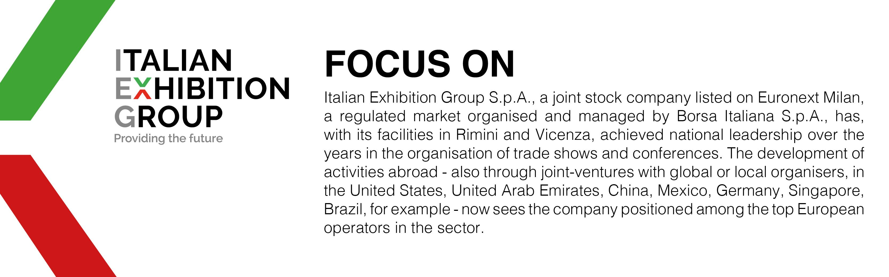

PRESS CONTACT ITALIAN EXHIBITION GROUP
Head of media relation & corporate communication: Elisabetta Vitali; press office manager: Marco Forcellini; international press office coordinator: Silvia Giorgi: media@iegexpo.it

MEDIA AGENCY: MYPR Lab
Filippo Nani, filippo.nani@myprlab.it; Enrico Bellinelli, enrico.bellinelli@myprlab.it; mob. +39 392 7480967; Francesca Magnanini, francesca.magnanini@myprlab.it; mob. +39 338 6910347

